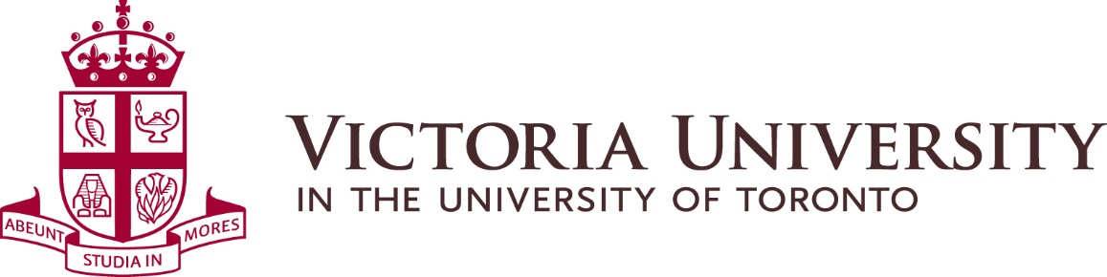

MINUTES OF MEETING OF THE
SUSTAINABILITY COMMITTEE
Held on February 27, 2019 from 10:00 am to 11:30 am
Copper Room

Present: Jared Connoy, Sustainability Commissioner
Victoria Silva, Sustainability Co-Chair
Vikas Mehta, Director Physical Plant
Shainiya Balachandran, Dean’s Office
Christina Alcena, Dean’s Office (alternate)

Absent: Ray DeSouza, Bursar and CAO
Ibrahim Hasan, Building President Representative

Recording Secretary: Véronique Morris, Physical Plant

Introduction:
Vikas Mehta initiated a round table introduction of all participants and introduced guest speaker Pr. John Robinson, Presidential Advisor on the Environment, Climate Change and Sustainability, at the University of Toronto.

Minutes:
Motion to approve the minutes of the previous meeting held on October 11, 2018. Carried.
Guest Speaker:
Prof. Robinson presented the work of the Committee on the Environment, Climate Change, and Sustainability (CECCS) at the University of Toronto. The Committee started working on January 2017 with a mandate to “advance coordination of the University’s contributions and objectives pertaining to research and innovation, academic programs, and sustainability initiatives related to our operations.” The Committee is comprised of staff, faculty, students and alumni and divided into 3 subcommittees: 1) Campus as Living Lab, 2) University as Agent of Change, and 3) Curriculum Innovation. Between February 2017 and November 2018, the CECCS has held 26 meetings and its mission is extended to 2020.

Prof. Robinson emphasized the need for an institutional culture change between academic and operational services to work together. He presented the six new and retrofit projects that have already been approved (two in each campus). The students’ involvement in these projects include shadow design, monitoring and research, design charrettes and study of process.

The Expanded Student Engagement (ESE) Research Group (made up of five undergraduate students) developed four sustainability-related inventories and one Sustainability Pathway report. The new sustainability course inventory holds 2022 courses and is available on the Sustainability Office web site. Another 154 community-engaged learning courses have also been accounted for at the University.

The CECCS is working with other external sustainability groups in Toronto and abroad to promote their approach to sustainability. To end, Prof. Robinson reviewed the goals of the CECCS.

A copy of Prof. Robinson’s presentation can be obtained at:
https://www.dropbox.com/s/ooz9jo6t7lwxdvf/CECCS%20Presentation%20Feb%202019.pdf?dl=0

A series of Questions and Answers followed.

Business arising from previous meeting:
Vikas Mehta informed the Committee that the installation of the bottle filling stations in the EJ Pratt Library is complete and well received by staff and students. Physical Plant will continue with bottle filling stations installs at other facilities at Vic over time.

The Dean’s office is currently holding orientation meetings during which they will discuss sustainability as part of the student mandatory training.

Future sustainability initiatives:
Vikas Mehta reiterated that the geothermal and other sustainability projects investigations are ongoing. UfT is working on a geothermal pilot project and Vikas to follow up with them to get further input on geothermal possibility at Vic.

Victoria Silva recommended that the signage for recycling in the residences be improved with the use of pictures, for instance. The Dean’s office will reach out to the Sustainability Commission during the summer to work on the signage.

Next meeting:
The next meeting will be scheduled for the end of September or the beginning of October 2019, time and place TBD.

